NAME: Surya Krishna Teja Yandra
REG NO:- 192425065

UMBRELLO EXPERIMENTS

EX 06 - Online Food Delivery Platform using Umbrello
AIM:
Design a Class Diagram, Use case Diagram and Activity Diagram for the Online Food Delivery System showing the relevant classes, their attributes, methods, and relationships.
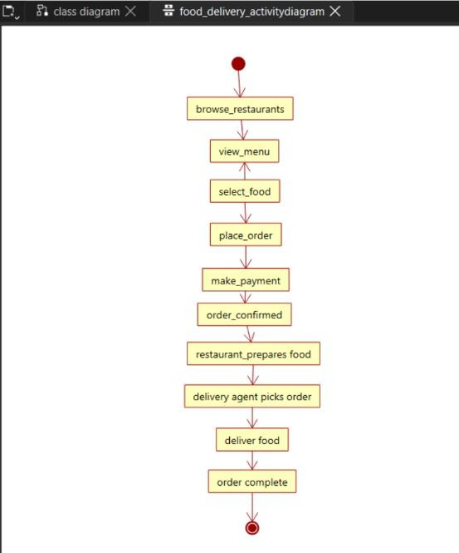

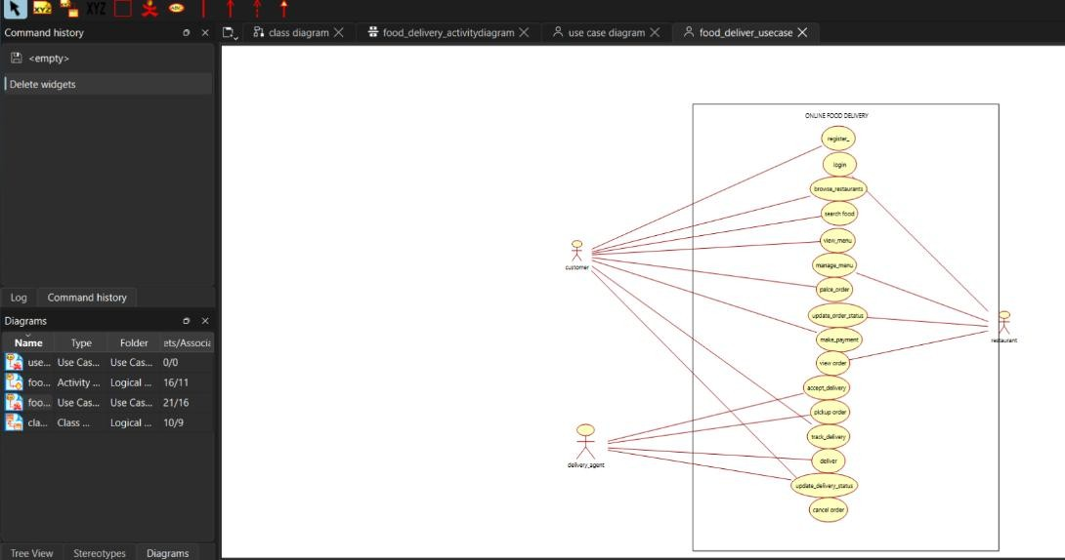
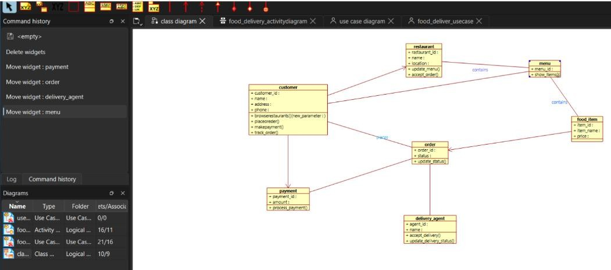

EX07 - Online Security Management System using Umbrello
AIM:-
Develop Class Diagram, Use case Diagram and Activity Diagram to represent the workflow of the Online Security Management System.

